**Title:**

**Authors:**

**Affiliations:**

**Corresponding Author:**

**Running Head:**

**Abstract:**

**Keywords:**

**Main Text:**

**INTRODUCTION**

**P1:** Environmental heterogeneity drives the spatiotemporal distribution of populations and individuals alike.

**P2:** Individual variability in movement strategies have been linked to XYZ

**P3:** While intraspecific variation is widespread in ecological data sets, studies have shown that environmental factors can act to synchronize ecological processes, animal movement, and space use.

**P4:**

**P5:**

**P6:**

**METHODS**

***Study Area***

* Citico Creek (35.5378 N, 84.1008 W) is a fourth-order tributary to the Little Tennessee River in Monroe County that flows into Tellico Reservoir, primarily through the Cherokee National Forest in eastern Tennessee (Figure 1).
* Anecdotal evidence suggests that the duration and timing of the annual spring buffalo migration in Citico Creek likely are influenced by abiotic conditions, specifically flow and temperature.
* We quantified nutrient subsidies from spawning buffalo in Citico Creek during the 2020 spring spawning migration from Tellico Reservoir.

***Migratory Buffalo Abundance Estimates***

* We estimated the daily abundance of buffalo in Citico Creek in order to quantify population-level nutrient subsidies throughout each migration wave.
* To collect aerial imagery, we established an 80-m longitudinal path for drone (DJI Phantom 4 Pro V2.0) flight at the 25th, 50th, and 75th percentiles of the total stream length occupied by buffalo on the day of image capture.
* To estimate the number of spawning adults in Citico Creek on days of maximum density for each wave, we sampled with replacement from the observed US and DS density distributions (Allgeier et al., 2020; Melia et al., 2020), with the number of draws from the distribution defined by the total area (m2)occupied by buffalo on that day.
* To estimate the daily abundance of spawning adults during each wave, we assumed unimodal temporal patterns in abundance over each wave (Childress & McIntyre, 2015), and we used linear interpolation to estimate the total number of spawning adults leading up to and following days of maximum density.

***Egg Estimates***

* We used data from ten females collected prior to spawning by recreational anglers to quantify nutrient subsidies from eggs, using linear regression to relate female body size (TL, cm) with ovary wet mass (kg).
* To determine N and P content of eggs deposited in Citico Creek, we first measured the water content of eggs by mass loss during oven drying (60°C, 48 h).
* Using larval emigration and egg deposition data, we estimated the nutrient contributions from eggs to Citico Creek.

***Excretion Estimates***

* To measure excretion rates of N and P, 47 live buffalo were captured using seines and incubated for 15-30 minutes in plastic tubs containing 30-60 L of fresh, unfiltered stream water.
* We measured excretion by individuals of both sexes across a range of body sizes to account for the potential effect of these factors on excretion rates. We generated a series of generalized linear models to examine the effects of temperature, mass, and sex on per-capita excretion rates.

***Carcass Estimates***

* Throughout the migration period, in-stream carcass subsidies were estimated daily by counting the number of carcasses across three 80-m reaches established at the 25th, 50th, and 75th percentiles of the total stream length occupied by buffalo.

***Dissolved Nutrient Concentration Estimates***

* To understand temporal changes in dissolved inorganic N (as NH4, nitrite [NO2]), and nitrate [NO3]) and P (as SRP) in Citico Creek, we collected duplicate water samples periodically (n = 33) from the thalweg of the export site between 5 March and 6 May 2020.
* To assess the ecological significance of nutrient subsidies from spawning adults during each wave, we calculated the ratio of migrant nutrient subsidy mass (whether eggs, excretion, or carcasses; Mw) to the total mass of nutrients exported for each wave (Ew).
* Visual examination of DIN, NH4, and SRP export (kg) throughout the 61-day sampling period was used to highlight potential in-stream nutrient dynamics­ associated with buffalo inputs.

**RESULTS**

***Migratory Buffalo Abundance***

* We observed three distinct waves of spawning buffalo between 18 March 2020 and 21 April 2020. Creek.

***Egg subsidies***

* Eggs were a substantial source of both N and P to Citico Creek during the 2020 spawning migration, representing the largest pathway for nutrient delivery to Citco Creek via buffalo (Figure 4).

***Excretion subsidies***

* Excretion was the second-largest pathway for nutrient subsidies during the 2020 spawning migration in Citico Creek (Figure 4).

***Carcass subsidies***

* Carcasses were the least important pathway for nutrients entering Citico Creek via buffalo.

***In-stream nutrient dynamics***

* The proportion of buffalo inputs relative to system export (i.e., Mw/Ew) varied among waves and compounds (i.e., DIN, NH4, and SRP), but was occasionally large.

**DISCUSSION**

* In aquatic environments, migratory fishes are a critical vector of material transport between habitats.
* Our results demonstrate that migrating buffalo can deliver large quantities of nutrients to a spawning tributary through different pathways, thereby underscoring an important dimension of ecological similarity between suckers such as buffalo and salmon.
* Migratory fish eggs have received little attention in freshwater ecology as a resource subsidy, which is surprising because eggs are an energy- and nutrient-rich resource that are readily accessible to a wide range of consumers.
* Beyond direct consumption, there are other pathways by which egg subsidies from migratory fishes may be incorporated into recipient ecosystems.
* Our results agree with other studies documenting the potential ecological importance of excretion by potamodromous, iteroparous fishes (Childress & McIntyre, 2015; Tronstad et al., 2015; Wheeler et al., 2015), and it is thus critical to understand the factors that influence excretion rates.
* Though the carcasses of iteroparous fishes are generally not important in delivering nutrients to their aquatic habitats (but see Flecker et al., 2010), it is possible that adjacent terrestrial food webs are being subsidized by their carcasses.
* The effects of migratory fish nutrient subsidies in recipient habitats depend on abiotic conditions and biotic characteristics of the organisms involved (Vanni, 2010).
* Future research aimed at quantifying the ecological importance of variability in spawning phenology would greatly improve our contextual understanding of sucker and salmon resource subsidies alike.
* The availability of N and P frequently limit primary production in freshwater ecosystems (Elser et al., 2007), so the magnitude and timing of resource subsidies from migratory fishes may have important implications for nutrient dynamics under different environmental conditions.
* Our results suggest buffalo delivered large N and P resource subsidies to Citico Creek during their spawning migrations in 2020.

**CONCLUSIONS**

* The results of our study highlight the potential magnitude of resource subsidies from spawning suckers despite their iteroparous life history.

**Acknowledgements:**

We would like to express our gratitude to Mark Rine, Jarrett Tallent, Caleb Moses, Abbey Holsopple, Gary Williams, and Ryan Hanscom for their assistance with field work and lab processing. Jordan Evans was instrumental in completing water and elemental analyses. Jim Herrig and Gary Williams both provided a wealth of local ecological knowledge that was extremely valuable in designing and completing our study. We would like to thank the Tennessee Wildlife Resource Agency and United States Forest Service for logistical support. Funding for this project was provided by Tennessee Technological University Department of Biology and Water Center. Feedback from anonymous reviewers, Evan Childress, Keith Gido, James Nelson, and the Tennessee Tech Stream Fish Ecology Lab substantially improved this manuscript.

**Data Availability Statement:**

Data are available from the first author upon reasonable request.

**Conflict of Interest:**

There are no conflicts of interest to declare.

**Author Contributions:**

**Mack White**: conceptualization; data curation; formal analysis; investigation; methodology; writing-original draft; writing-review and editing. **Kit Wheeler**: conceptualization; data collection; funding acquisition; methodology; project administration; writing-original draft; writing-review and editing. **Ryan Hudson**: data collection; investigation; writing-review and editing. **Justin Murdock**: conceptualization; methodology; writing-review and editing.

**References:**

Allgeier, J.E., Cline, T.J., Walsworth, T.E., Wathen G, Layman, C.A., & Schindler D.E. (2020). Individual behavior drives ecosystem function and the impacts of harvest. *ScienceAdvances, 6*, 1-9.

Basu, N.B., Destouni, G.W., J., Jawitz, S.E., Thompson, N.V., Loukinova, A., et al. (2010). Nutrient loads exported from managed catchments reveal emergent biogeochemical stationarity. *Geophysical Research Letters, 37*, L23404.

Bilby, R.E., Fransen, B.R., & Bisson, P.A. (1996). Incorporation of nitrogen and carbon from spawning coho salmon into the trophic system of small streams: evidence from stable isotopes. *Canadian Journal of Fisheries and Aquatic Sciences, 53*, 164-173.

Cederholm, C.J., Kunze, M.D., Murota, T., & Sibatani, A. (1999). Pacific salmon carcasses: essential contributions of nutrients and energy for aquatic and terrestrial ecosystems. *Fisheries*, *24*, 6-15.

Collins, S.F., Moerke, A.H., Chaloner, D.T., Janetski, D. J., & Lamberti, G. A. (2011). Response of dissolved nutrients and periphyton to spawning Pacific salmon in three northern Michigan streams. *Journal of the North American Benthological Society*, *30*(3), 831-839.

Cooke, S.J. & Bunt, C.M. (1999). Spawning and Reproductive Biology of the Greater Redhorse, *Moxostomo valenciennesi*, in the Grand River, Ontario. *The Canadian Field Naturalist, 113*, 497-502.

Cooke, S.J., Blunt, C.M., Hamilton, S.J., Jennings, C.A., Pearson, M.P., Cooperman, M.S., & Markle, D.F. (2005). Threats, conservation strategies, and prognosis for suckers (Catostomidae) in North America: insights from regional case studies of a diverse family of non-game fishes. *Biological Conservation*, *121*, 317-331.

Cordoleani F., Noch, J., McHuron, A.S., Ammann, A.J., & Michel, C.J. (2018). Movement and Survival of Wild Chinook Salmon Smolts from ButteCreek During Their Out-Migration to the Ocean: Comparison of a DryYear versus a Wet Year. *Transactions of the American Fisheries Society, 147*, 171-184.

Childress, E.S. (2014). *Cross-Ecosystem delivery of nutrients to streams: The role of fish migrations and landscape processes.* (Publication No. 3642882) [Doctoral dissertation, The University of Wisconsin - Madison]. ProQuest Dissertations & Theses Global.

Childress, E.S. & McIntyre, P.B. (2015). Multiple nutrient subsidy pathways from a spawning migration of iteroparous fish. *Freshwater Biology,* *60*, 490-499.

Childress, E.S., Papke, R., & McIntyre, P.B. (2016). Spawning success and early life history of longnose suckers in Great Lakes tributaries. *Ecology of Freshwater Fish, 25,* 393-404.

Clifford, H.F. (1972). Downstream movements of white sucker, *Catostomus* *commersonii*, in a brown-water stream of Alberta*. Journal of Fisheries Research Board of Canada, 29,* 1091-1093.

Curry, K.D. & Spacie, A. (1984). Differential use of stream habitat by spawning catostomids. *American Midland Naturalist, 111*, 267-279.

Dahlberg, M.D. (1979). Review of survival rates of fish eggs and larvae in relation to impact assessments. *Marine Fisheries Review, 41*, 1-12.

Deacy, W.W., Leacock, W.B., Stanford, J.A., & Armstrong, J.B. (2019). Variation in spawning phenology within salmon populations influences landscape-level patterns of brown bear activity. *Ecosphere 10*(1): e02575.

Dean, E.M., Cooper, A.R., Wang, L., Daniel, W., David, S., Ernzen, C., Gido, K.B., Hale, E., Haxton, T.J., Kelso, W. and Leonard, N. (2022). The North American Freshwater Migratory Fish Database (NAFMFD): Characterizing the migratory life histories of freshwater fishes of Canada, the United States and Mexico. *Journal of Biogeography*, *49*, 1193-1203.

Denton, K.P., Rich Jr., H.B., & Quinn, T.P. (2009). Diet, Movement, and Growth of Dolly Varden in Response to Sockeye Salmon Subsidies. *Transactions of the American Fisheries Society, 138*, 1207-1219.

Dinkins, G.R. (1984). *Aspects of the life history of the Smoky Madtom, Noturus baileyi Taylor, in Citico Creek*. [Master’s Thesis, University of Tennessee]. Tennessee Research and Creative Exchange. https://trace.tennessee.edu/cgi/viewcontent.cgi?article=5692&context=utk_gradthes.

Elser, J.J., Bracken, M.E.S., Cleland, E.E., Gruner, D.S., Harpole, W.S., Hillebrand, H., Ngai, J.T., Seabloom, E.W., Shurin, J.B., & Smith, J.E. (2007). Global analysis of nitrogen and phosphorus limitation of primary producers in freshwater, marine and terrestrial ecosystems. *Ecology letters* *10*(12)*,* 1135-1142.

Evans, D.H. (1993). *The Physiology of Fishes: Osmotic and Ionic Regulation* (1st ed). Boca Raton, FL: CRC Press.

Fausch, K.D., Torgersen, C.E., Baxter, C.V., & Li, H.W. (2002). Landscapes to riverscapes: bridging the gap between research and conservation of stream fishes: a continuous view of the river is needed to understand how processes interacting among scales set the context for stream fishes and their habitat. *BioScience, 52*(6), 483-498.

Flecker, A.S., McIntyre, P.B., Moore, J.W., Anderson, J.T., Taylor, B.W., & Hall Jr., R.O. (2010). Migratory fishes as material and process subsidies in riverine ecosystems. *American Fisheries Society Symposium*, *73*, 559-592.

Fuiman, L.A., Connelly, T.L., Lowerre-Barbieri, S.K., & McClelland J.W. (2015). Egg boons: central components of marine fatty acid food webs. *Ecology, 96*, 362-372.

Gende, S.M., Edwards, R.T., Willson, M.F., & Wipfli, M.S. (2002). Pacific Salmon in Aquatic and Terrestrial Ecosystems: Pacific salmon subsidize freshwater and terrestrial ecosystems through several pathways, which generates unique management and conservation issues but also provides valuable research opportunities. *BioScience 52*(10), 917-928.

Geen, G.H., Northcote, T.G., Hartman, G.F., & Lindsey, C.C. (1966). Life histories of two species of catostomid fishes in Sixteenmile Lake, British Columbia, with particular reference to inlet stream spawning. *Journal of the Fisheries Research Board of Canada, 23,* 1761-1788.

Godsey, S.E., Kirchner, J.W., & Clow, D.W. (2009). Concentration-discharge relationships reflect chemostatic characteristics of US catchments. *Hydrological Processes, 23*, 1844– 1864.

Groot, C. & Margolis, L. (1991). *Pacific Salmon Life Histories*. Vancouver, BC: UBC Press.

Holmes R.M., Amonit, A., Kerouel, R., Hooker, B.A., & Peterson, B.J. (1999). A simple and precise method for measuring ammonium in marine and freshwater ecosystems. *Canadian Journal of Fisheries and Aquatic Sciences*, *56*, 1801-1808.

Holtgrieve, G.W. & Schindler, D.E. (2011). Marine-derived nutrients, bioturbation, and ecosystem metabolism: reconsidering the role of salmon in streams. *Ecology, 92*, 373-385.

IPBES (2019). Global assessment report on biodiversity and ecosystem services of the Intergovernmental Science-Policy Platform on Biodiversity and Ecosystem Services (IPBES). Brondizio, E.S., Settele, J., Diaz, S., & Ngo, H.T. (editors).

Janetski, D.J., Chaloner, D.T., Tiegs, S.D., & Lamberti, G.A. (2009). Pacific salmon effects on stream ecosystems: a quantitative synthesis. *Oecologica,* *159*, 583-595.

Janetski, D.J., Chaloner, D.T., Moerke, A.H., Levi, P.S., & Lamberti, G.A. (2014). Novel environmental conditions alter subsidy and engineering effects by introduced Pacific salmon. *Canadian Journal of Fisheries and Aquatic Sciences*, *71*(4), 502-513.

Jones, N.E. & Mackereth, R.W. (2016). Resource subsidies from adfluvial fishes increase stream productivity. *Freshwater Biology,* *61*, 991-1005.

Kiszka J.J., Mourier, J., Gastrich, K., & Heithaus, M.R. (2016). Using unmanned aerial vehicles (UAVs) to investigate shark and ray densities in a shallow coral lagoon. *Marine Ecology Progress Series, 560*, 237-242.

Koshino Y., Kudo H., & Kaeriyama, M. (2013). Stable isotope evidence indicates the incorporation into Japanese catchments of marine-derived nutrients transported by spawning Pacific salmon. *Freshwater Biology, 58*,1864-1877.

Lucas, M.C. & Baras, E. (2001). *Migration of Freshwater Fishes*. Osney Mead, Oxford: Blackwell Science Ltd.

MacDonald, D.G. (1978). Life history studies of the smallmouth buffalo, *Ictiobus bubalus* (Rafinesque), in Watts Bar and Chickamauga Reservoirs, Tennessee. [Master’s thesis, Tennessee Technological University].

Mattocks, S., Hall, C.J., & Jordaan, A. (2017). Damming, lost connectivity, and the historical role of anadromous fish in freshwater ecosystem dynamics. *BioScience, 67*, 713-728.

McIntyre, P.B. & Flecker, A.S. (2010). Ecological stoichiometry as an integrative framework in stream fish ecology. *American Fisheries Society Symposium, 73*, 539-558.

Melia, P., Casagrandi, R., Franco, A.D., Guidetti, P., & Gatto, M. (2020). Protection reveals density-dependent dynamics in fish populations: A case study in the central Mediterranean. *PlosOne*, https://doi.org/10.1371./journal.pone.0228604.

Mion, J.B., Stein, R.A., & Marschall, E.A. (1998). River discharge drives survival of larval walleye. *Ecological Applications, 8*, 88-103.

Moatar, F., Abbott, B.W., Minaudo, C., Curie, F., & Pinay, G. (2017). Elemental properties, hydrology, and biology interact to shape concentration-discharge curves for carbon, nutrients, sediment, and major ions. *Water Resources Research, 53*, 1270-1287.

Moore, J.W., Schindler, D.E., Carter, J.L., Fox, J., Griffiths, J., & Holtgrieve, G.W. (2007). Biotic control of stream fluxes: spawning salmon drive nutrient and matter export. *Ecology*, *88*(5), 1278-1291.

Naiman, R.J., Bilby, R.E., Schindler, D.E., & Helfield, J.M. (2002). Pacific salmon, nutrients, and the dynamics of freshwater and riparian ecosystems. *Ecosystems*, *5*(4), 399-417.

Newell, F.L. & Rodewald, A.D. (2011). Role of topography, canopy structure, and floristics in nest-site selection and nesting success of canopy songbirds. *Forest Ecology and Management, 262*, 739-749.

Peterson, B.J., Wollheim, W.M., Mulholland, P.J., Webster, J.R., Meyer, J.L., Tank, J.L., Marti, E., Bowden, W.B., Valett, H.M., Hershey, A.E. & McDowell, W.H. (2001). Control of nitrogen export from watersheds by headwater streams. *Science, 292*(5514), 86-90.

Piller, K.R., Bart, H.L., & Tipton, J.A. (2003). Spawning in black buffalo, *Ictiobus niger* (Cypriniformes: Catostomidae). *Ichthyological Exploration of Freshwaters*, *14,* 145-150.

Polis, G.A., Anderson, W.B., & Holt, R.D. (1997). Towards an integration of landscape and food web ecology: the dynamics of spatially subsidized food webs. *Annual Review of Ecology and Systematics, 28*, 289-316.

Purcell, J.E. (1985). Predation on fish eggs and larvae by pelagic cnidarians and ctenophores. *Bulletin of Marine Science, 37*, 739-755.

Rypel, A.L., Saffarinia, P., Vaughn, C.C., Nesper, L., O’Reilly, K., Parisek, C.A., Miller, M.L., Moyle, P.B., Fangue, N.A., Bell-Tilcock, M., Ayers, D., & David, S.R. (2021). Goodbye to “rough fish”: paradigm shift in the conservation of native fishes. *Fisheries, 46*, 605-616.

Schindler, D.E., Scheuerell, M.D., Moore, J.W., Gende, S.M., Francis, T.B., & Palen, W.J. (2003). Pacific salmon and the ecology of coastal ecosystems. *Frontiers in Ecology and the Environment, 1*(1), 31-37.

Schlosser, I.J. & Angermeier, P.L. (1995). Spatial variation in demographic processes of lotic fishes: conceptual models, empirical evidence, and implications for conservation. *American Fisheries Society Symposium, 17*, 392-401.

Scheuerell, M.D., Moore, J.W., Schindler, D.E., & Harvey, C.J. (2007). Varying effects of anadromous sockeye salmon on the trophic ecology of two species of resident salmonids in southwest Alaska. *Freshwater Biology*, *52*(10), 1944-1956.

Subalusky, A.L. & Post, D.M. (2019). Context dependency of animal resource subsidies. *Biological Reviews, 94*, 517-538.

Taylor, B.W., Keep, C.F., Hall Jr, R.O., Kock, B.J., & Tronstad, L.M. (2007). Improving the fluorometric ammonium method: matric effects, background fluorescence, and standard additions. *Journal of the North American Benthological Society, 26*, 167-177.

Tiegs, S.D., Levi, P.S., Ruegg, J., Chaloner, D.T., Tank, J.L., & Lamberti, G.A. (2011). Ecological effects of live salmon exceed those of carcasses during an annual spawning migration. *Ecosystems, 14*, 598-614.

Tronstad, L.M., Hall Jr, R.O., & Koel, T.M. (2015). Introduced lake trout alter nitrogen cycling beyond Yellowstone Lake. *Ecosphere, 6*, 1-24.

van Rees, E. (2015). Creating Aerial Drone Maps Fast. *GeoInformatics, 18*, 24-25.

Vanni, M.J. (2002). Nutrient cycling by animals in freshwater ecosystems. *Annual Review of Ecology and Systematics*, *33*, 341-370.

Vanni, M.J. (2010). Preface: when and where do fish have strong effects on stream ecosystem processes. *American Fisheries Society Symposium*, *73*, 531-538.

Warren Jr., M.L. & Burr, B.M. (2014). *Freshwater Fishes of North America 1: Petromyzontidae to Catostomidae.* Baltimore, MD: Johns Hopkins University Press.

West, D., Walters, A.W., Gephard, S., & Post, D.M. (2010). Nutrient loading by anadromous alewife (*Alosa pseudoharengus*): Contemporary patterns and predictions for restoration efforts*. Canadian Journal of Fisheries and Aquatic Sciences*, *67*, 1211-1220.

Wheeler, K., Miller, S.W., & Crowl, T.A. (2015). Migratory fish excretion as a nutrient subsidy to recipient stream ecosystems. *Freshwater Biology, 60*, 537-550.

White, M. (2021). Nutrient Contributions from and Early Life History Variability of an Adfluvial Sucker in an Oligotrophic Southeastern Stream. (Publication No. 28416646) [Master’s thesis, Tennessee Technological University]. ProQuest Dissertations & Theses Global.

Whiles, M.R., Huryn, A.D., Taylor, B.W., & Reeve, J.D. (2009). Influence of handling stress and fasting on estimates of ammonium excretion by tadpoles and fish: recommendations for designing excretion experiments. *Limnology and Oceanography: Methods, 7*, 1-7.

Wrenn, W.B. (1969). Life history aspects of smallmouth buffalo and freshwater drum in Wheeler Reservoir, Alabama. *Proceedings of Southeastern Association of Game and Fish Commission, 22,* 479-495*.*

## **FIGURES:**

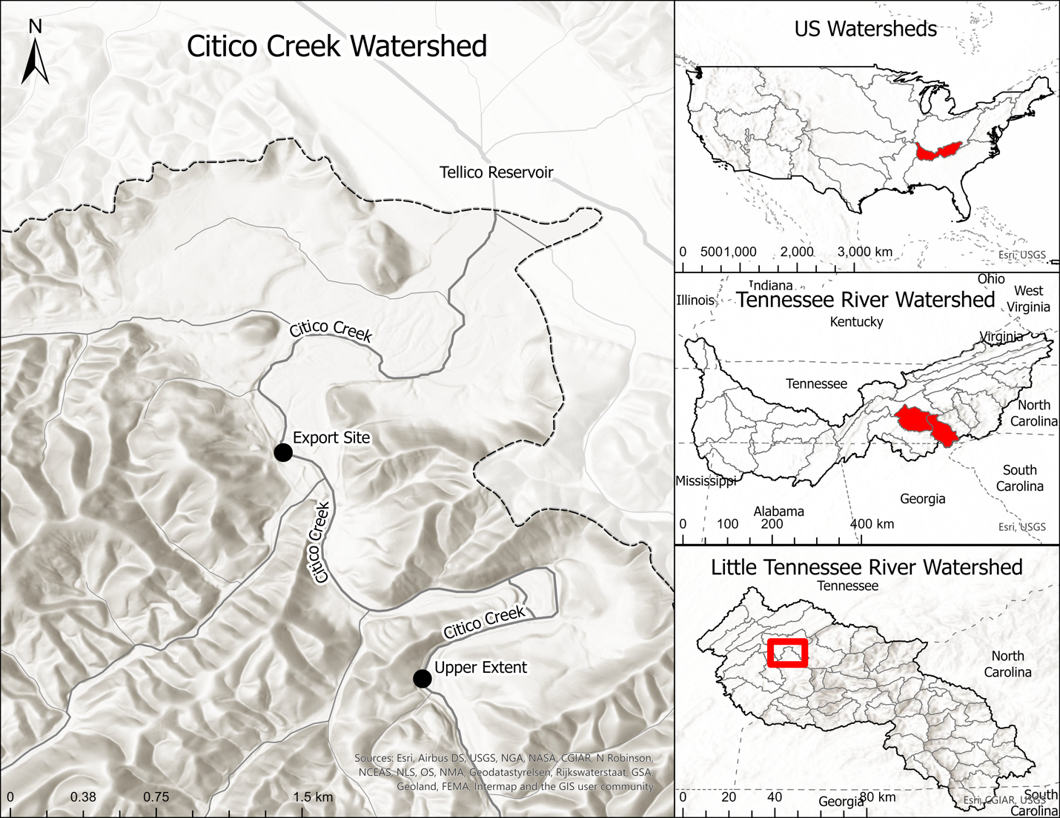

**Figure 1.** Location of Citico Creek and Tellico Reservoir in Monroe County, Tennessee, USA. The export site, immediately above reservoir influence and where all in-stream nutrient concentration data were collected, is represented by the most downstream point within Citico Creek, relative to Tellico Reservoir. The farthest upstream point at which we observed adult Smallmouth Buffalo during 2020 is represented by the upper extent point.

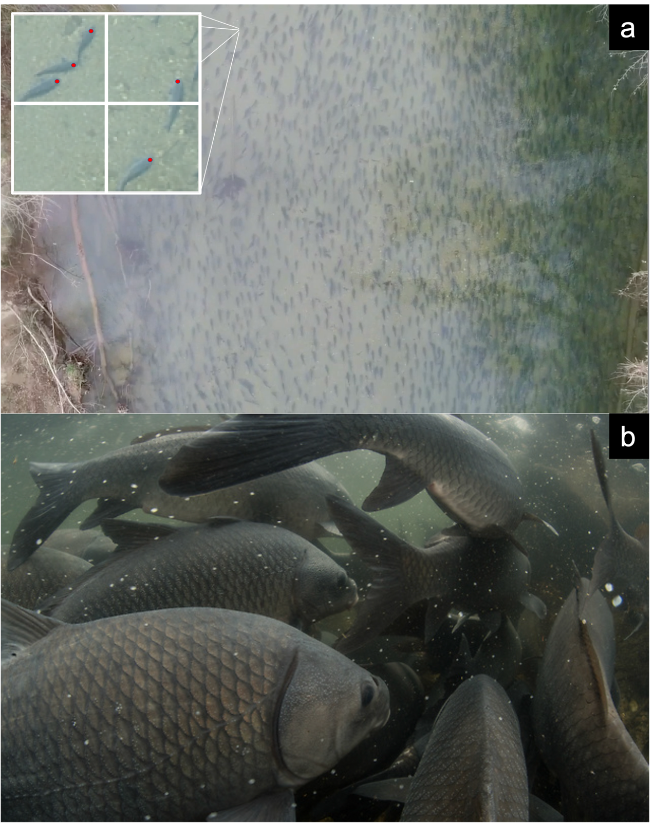

**Figure 2.** Spawning aggregation of migratory Smallmouth Buffalo (*Ictiobus bubalus*) in Citico Creek pictured from (a) above on 19 March 2020 with grid-sampling inlay to represent method of estimating density from aerial imagery; red dots indicate individual buffalo counted within each 1 x 1 m grid cell and (b) underwater spawning aggregation. Photo credits: (a) Mack White/Tennessee Technological University; (b) David Herasimtschuk/Freshwaters Illustrated.

**Figure 3.** Discharge (m3/s) and temperature (°C) estimates across the 61-day sampling period. Shaded grey bars indicate periods when migratory adult Smallmouth Buffalo were present. No spawning adults were observed in the system between grey bars. Estimates of discharge (m3/s) were generated using the relationship between measured discharge values in Citico Creek and hourly discharge measurements from the nearby Tellico River USGS streamgage (USGS 03518500; *R2* = 0.49, n = 60). Average daily estimates of water temperature (°C) were generated using the relationship between observed water temperature measurements in Citico Creek and air temperature measurements at a nearby weather station (*R2* = 0.76, n = 312).

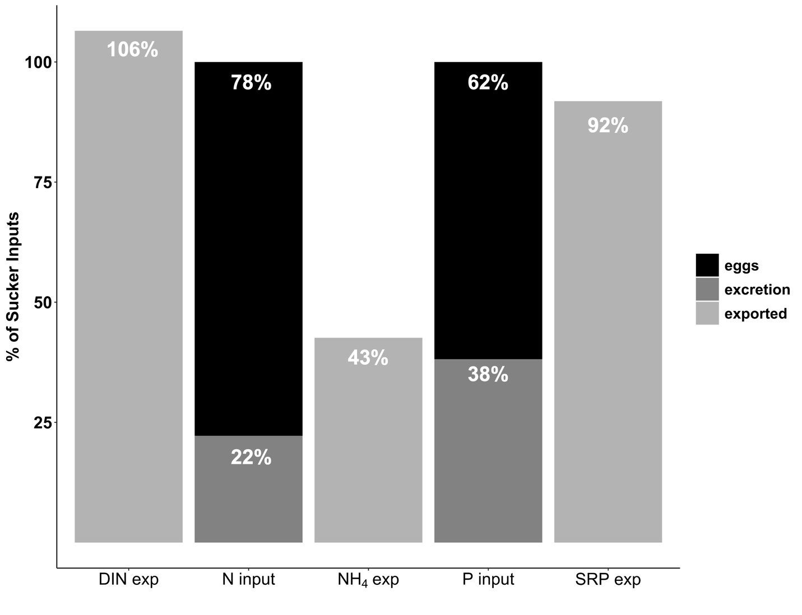

**Figure 4.** Different pathways by which spawning Smallmouth Buffalo delivered nitrogen (N) and phosphorus (P) to Citico Creek during the 2020 migration period. Egg and excretion inputs were calculated over the entire migration period. Export (exp) of N (as NH4 and dissolved inorganic nitrogen, DIN) and P (as soluble reactive phosphorus, SRP) is shown as a proportion of migrant buffalo contributions. Percentages for N and P inputs represent proportions of total attributed to eggs and excretion.

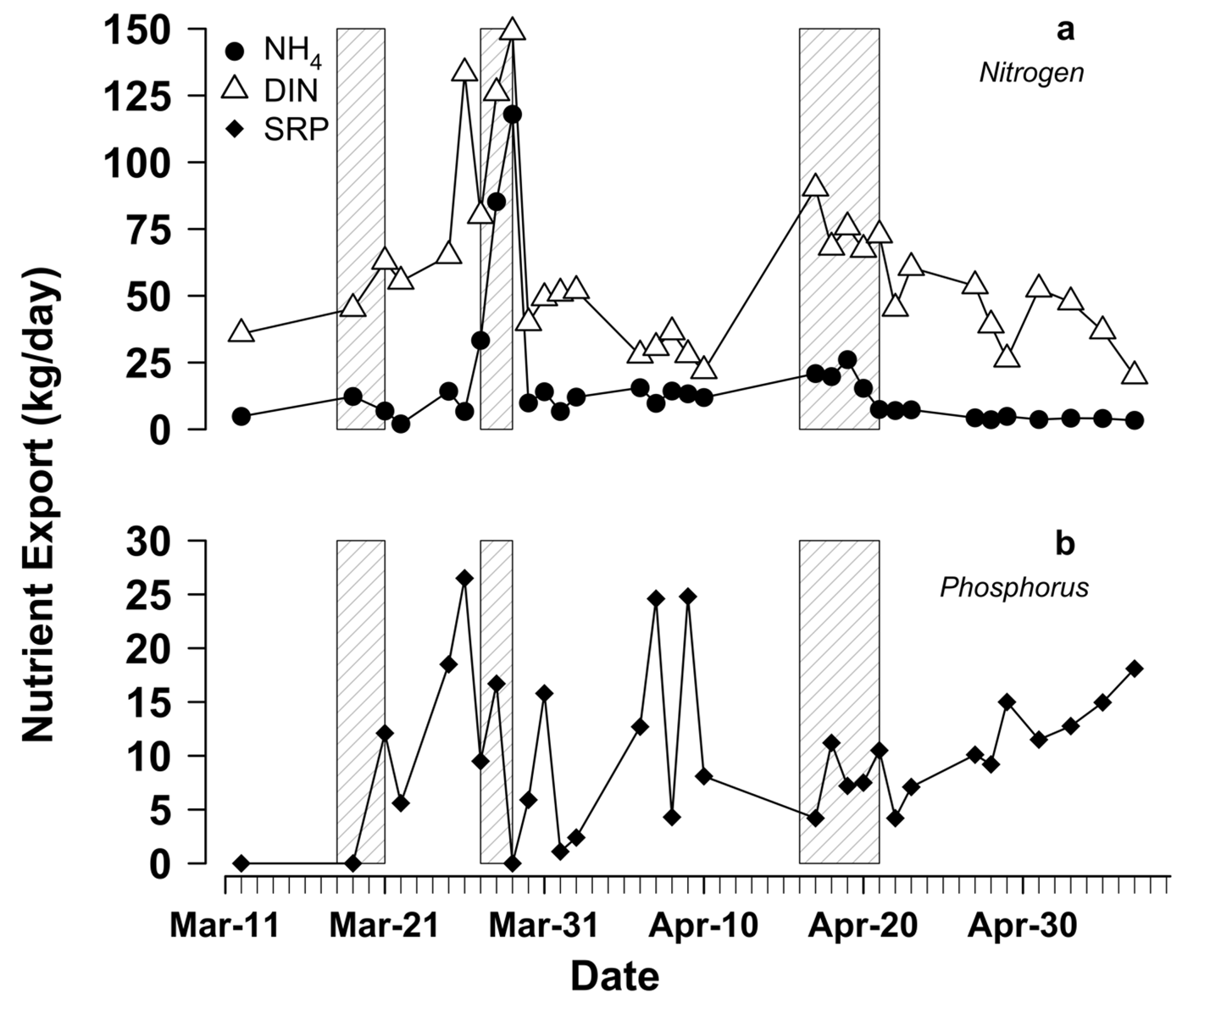

**Figure 5.** Mass of nutrients exported (kg) from Citico Creek across the 61-day sampling period for (a) total dissolved inorganic nitrogen (DIN; NH4 + NO2 + NO3), ammonium (NH4), and (b) soluble reactive phosphorus (SRP). Note the differences in *y*-axis scales for nitrogen and phosphorus. Points in each plot represent days when water was sampled from the export site. Linear interpolation was used to estimate system export on days when in-stream nutrient samples were not collected. Shaded grey bars indicate periods when migratory adult Smallmouth Buffalo were present. No adult migrants were observed in the system between grey bars.

**TABLES:**

**Table 1.** Estimates for abundances of all spawning adult and female Smallmouth Buffalo, egg deposition, larval buffalo emigration, and egg retention during each wave of the 2020 Citico Creek spawning migration (mean and 95% confidence intervals). We assumed complete washout of eggs and larvae following wave one, so larval emigration data were not collected (see text). Values presented here do not assume that individual adults were present in Citico Creek during only one wave.

|  |  |  |  |
| --- | --- | --- | --- |
|  | **WAVE ONE** | **WAVE TWO** | **WAVE THREE** |
| **SPAWNING ADULTS** | 31,380 (30,861 - 31,912) | 53,216 (52,537 - 53,898) | 67,619 (66,847 - 68,412) |
| **FEMALES** | 12,251 (12,048 - 12,459) | 20,776 (20,511 - 21,042) | 26,399 (26,098 - 26,709) |
| **EGGS (kg)** | 3,789 (3,731-3,840) | 6,424 (6,352-6,487) | 8,162 (8,082-8,233) |
| **EGGS (#; × 106)** | 1925 (1896-1951) | 3264 (3228-3296) | 4148 (4107-4184) |
| **LARVAE (#; × 106)** | NA | 14.6 | 143.2 |
| **RETENTION (%)** | 0 | 99.6 (99.6-99.7) | 96.6 (96.6-96.7) |

**Table 2.** Buffalo nutrient subsidies during the 2020 Citico Creek spawning migration (mean and 95% confidence intervals). Bold values indicate the total contribution for each nutrient during each wave.

|  |  |  |  |
| --- | --- | --- | --- |
|  | **WAVE ONE** | **WAVE TWO** | **WAVE THREE** |
| **EGGS (kg) - N** | 0.00 (0.00 - 0.00) | 254.41 (251.44 – 257.10) | 313.25 (309.36 – 317.01) |
| **EGGS (kg) - P** | 0.00 (0.00 - 0.00) | 22.26 (22.00 – 22.50) | 27.43 (27.12 – 27.74) |
| **EXCRETION (kg) - N** | 34.38 (33.80 – 34.96) | 73.77 (72.84 - 74.70) | 54.11 (53.50 - 54.74) |
| **EXCRETION (kg) - P** | 6.04 (5.93 – 6.14) | 5.76 (5.75 - 5.78) | 18.86 (18.64 - 19.08) |
| **TOTAL (kg) - N** | **34.38 (33.80 - 34.96)** | **328.28 (324.28 - 331.76)** | **367.45 (362.86 - 371.75)** |
| **TOTAL (kg) - P** | **6.04 (5.93 - 6.14)** | **28.02 (27.75 - 28.28)** | **46.29 (45.76 - 46.82)** |

**Table 3.** Summary of watershed export, import of N from spawning buffalo (mean and 95% confidence intervals), and comparisons of estimated nutrient subsidies during each wave with watershed export of dissolved inorganic nitrogen (DIN) and ammonium (NH4) during the 2020 Citico Creek spawning migration.

|  |  |  |  |
| --- | --- | --- | --- |
|  | **WAVE ONE** | **WAVE TWO** | **WAVE THREE** |
| **N INPUTS (kg)** | 34.38 (33.80 - 34.96) | 328.28 (324.28 - 331.76) | 367.45 (362.86 - 371.75) |
| **DIN EXPORT (kg)** | 135.33 | 320.17 | 321.99 |
| **NH4EXPORT (kg)** | 27.22 | 211.82 | 71.98 |
| **Mw/Ew (DIN)** | 0.25 | 1.03 | 1.14 |
| **Mw/Ew (NH4)** | 1.26 | 1.55 | 5.10 |

**Table 4.** Summary of watershed export, import of P from spawning buffalo (mean and 95% confidence intervals), and comparisons of estimated nutrient subsidies during each wave with watershed export of dissolved inorganic phosphorus (SRP) during the 2020 Citico Creek spawning migration.

|  |  |  |  |
| --- | --- | --- | --- |
|  | **WAVE 1** | **WAVE 2** | **WAVE 3** |
| **P INPUTS (kg)** | 6.04 (5.93 - 6.14) | 28.02 (27.75 - 28.28) | 46.29 (45.76 - 46.82) |
| **SRP EXPORT (kg)** | 12.34 | 26.53 | 34.93 |
| **Mw/Ew (SRP)** | 0.49 | 1.06 | 1.33 |